**Create a simple Azure function that should trigger as soon as you upload a file in the blob storage. Function should be able to print the name of the file uploaded in the Azure function.**

1.Select Function App from Azure Portal. Add Resource Group and Function App Name.Select Regoin and Publish .

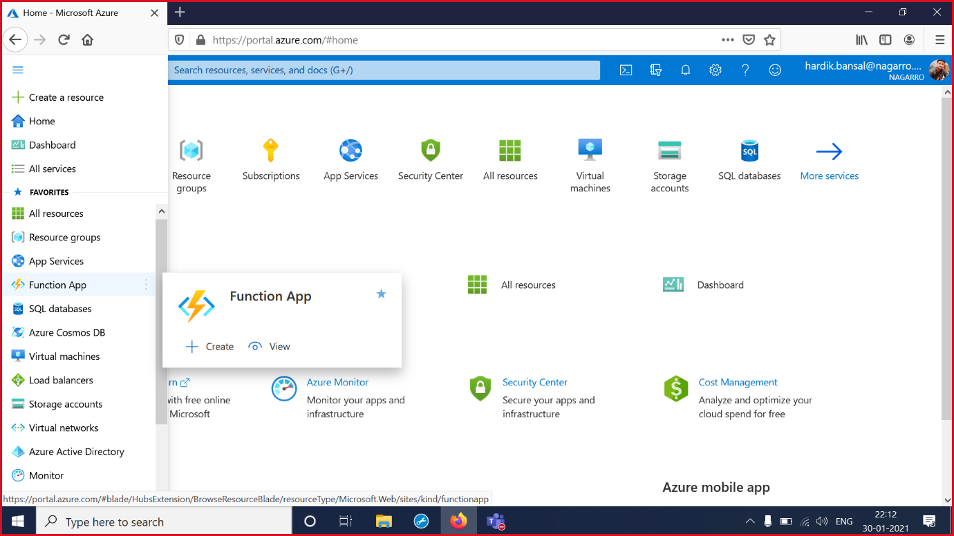

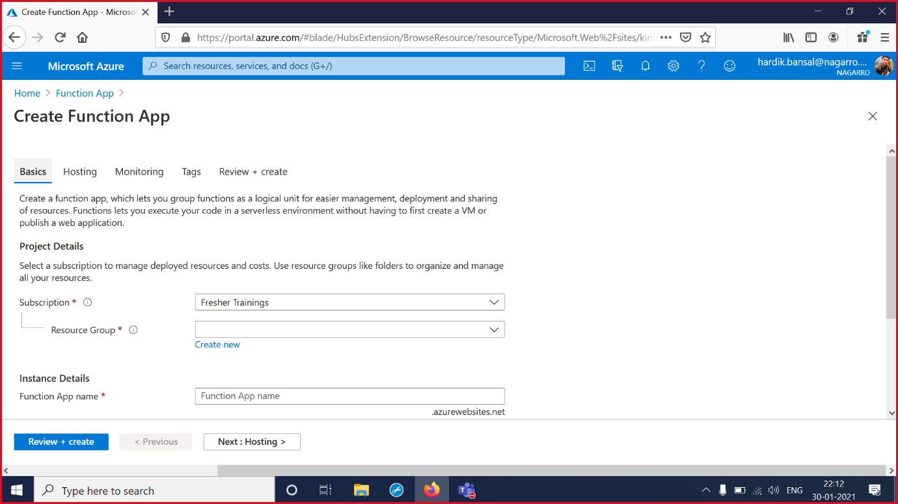

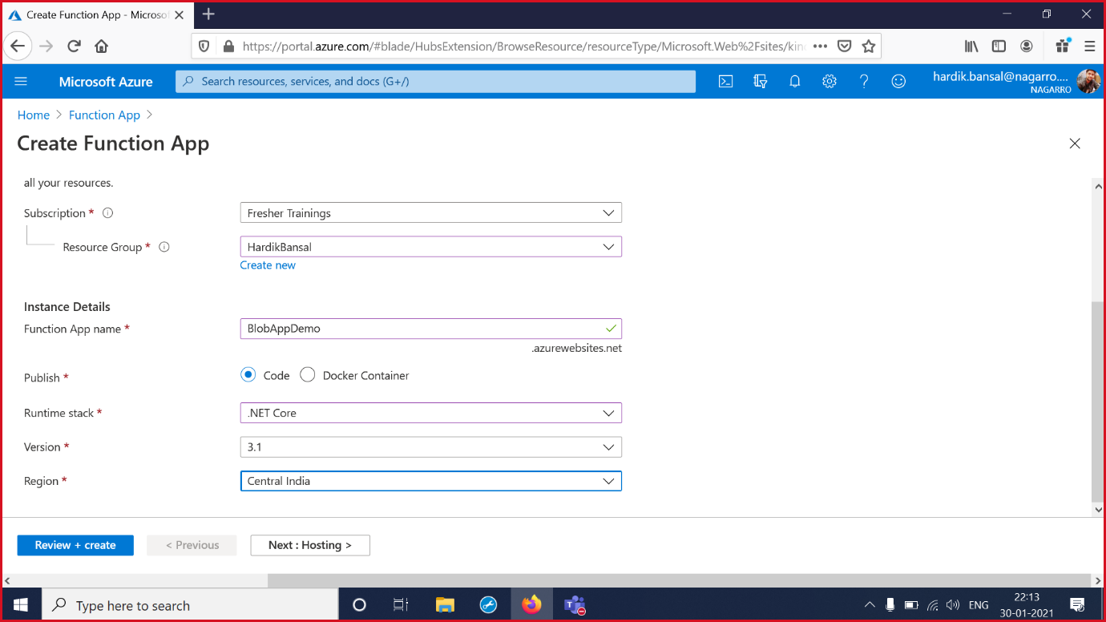

2.Select Review and Create and Then select Create to create Function App .

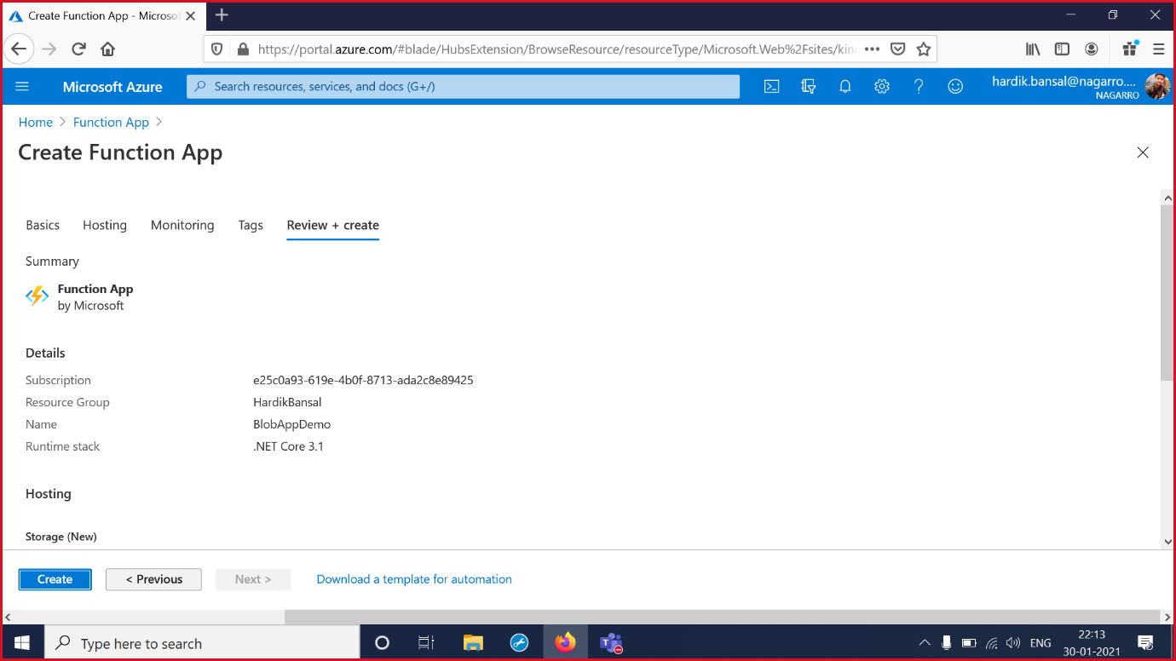

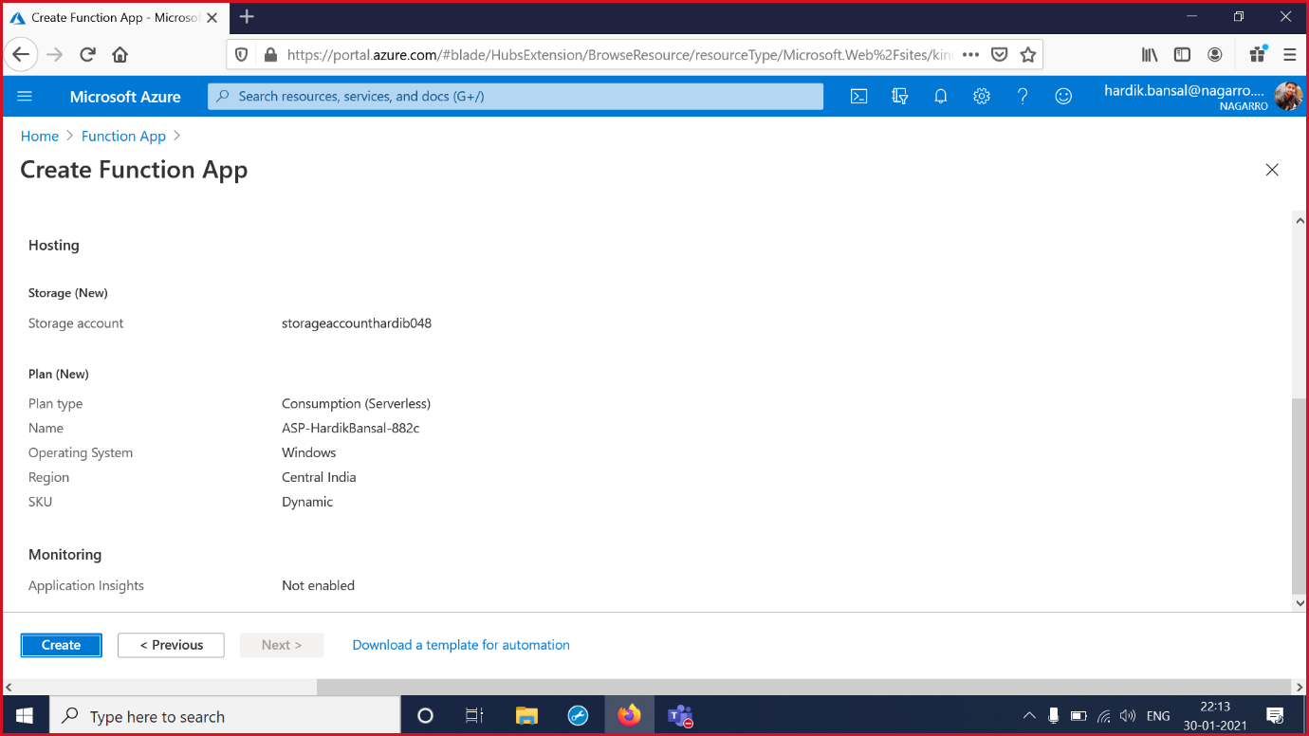

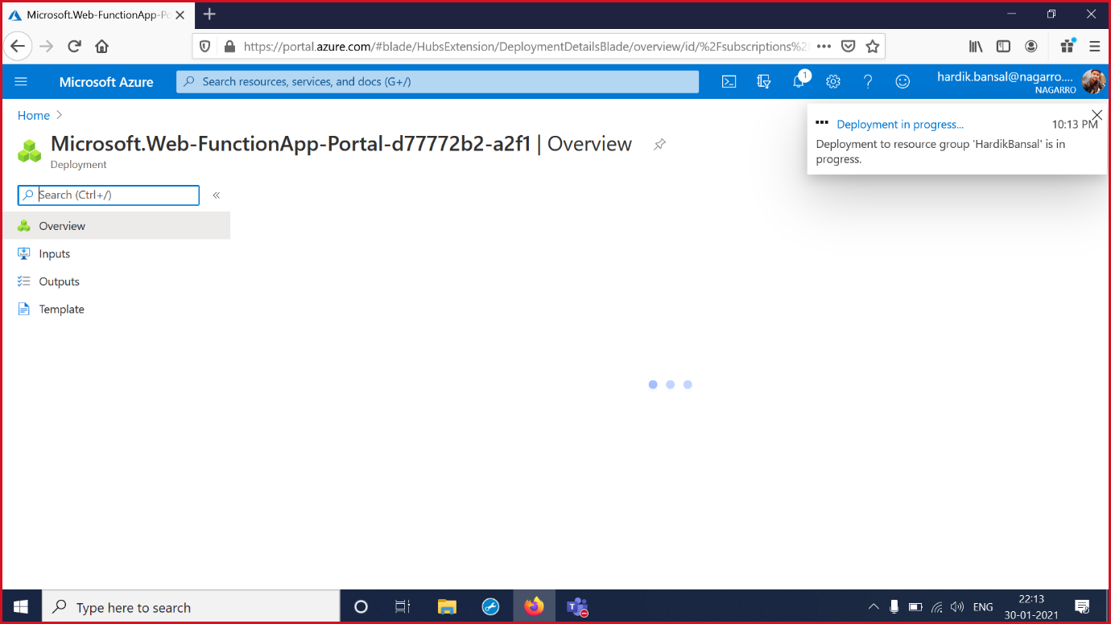

3.Deployed the Function App to The Portal. Check the Overview

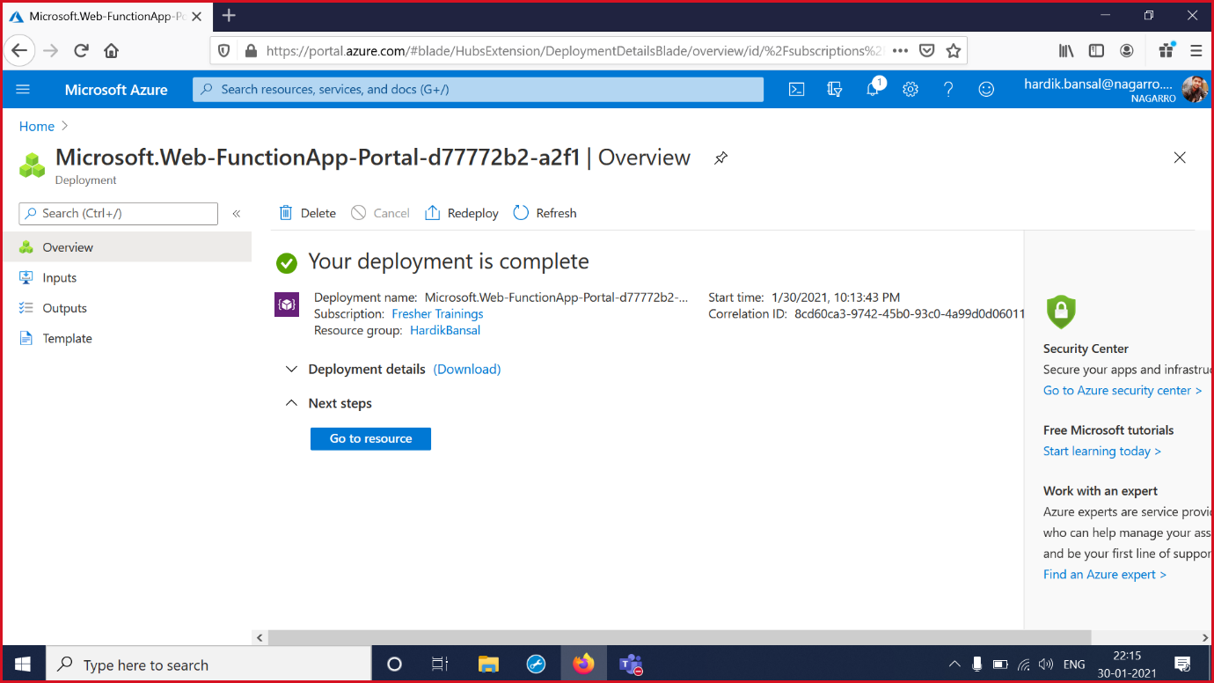

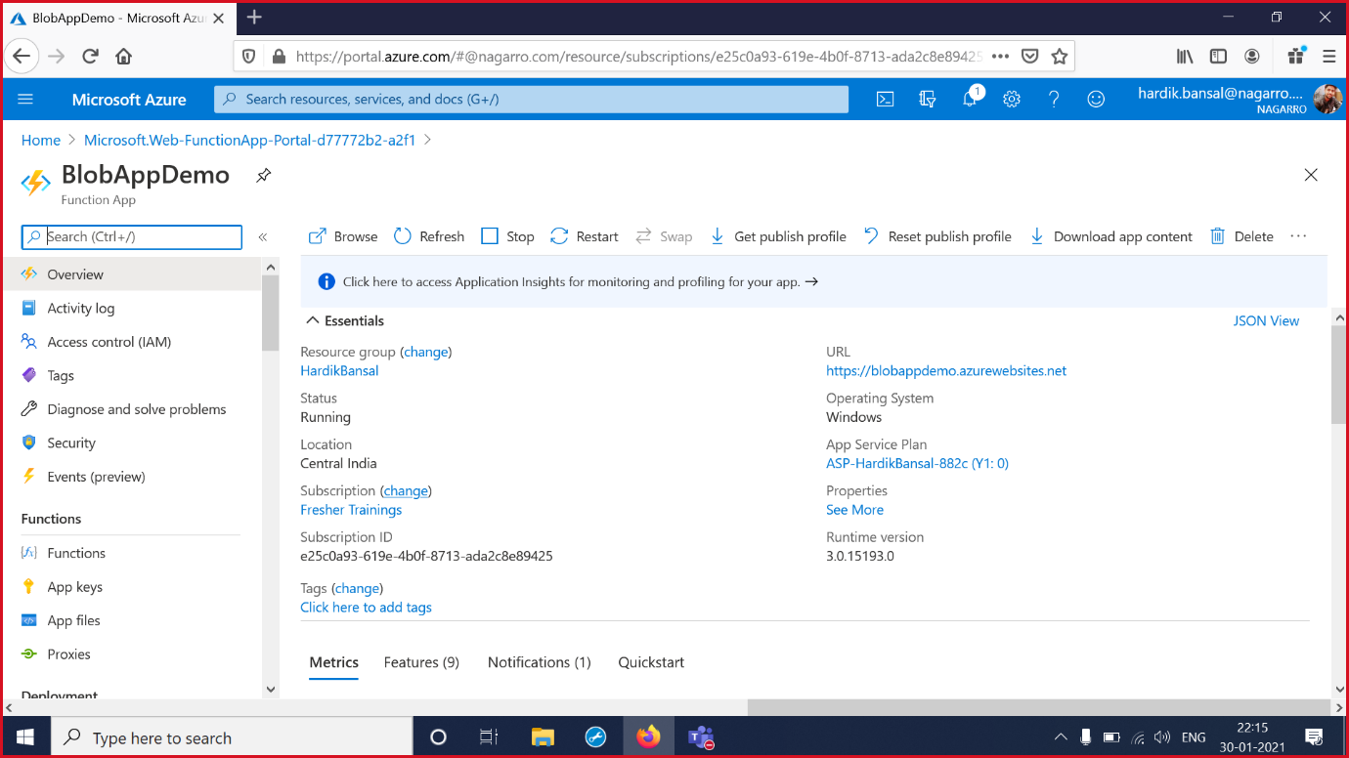

4. Select Generated Function App and then Select Functions .Add the Azure Blob Storage Trigger and Function is created.

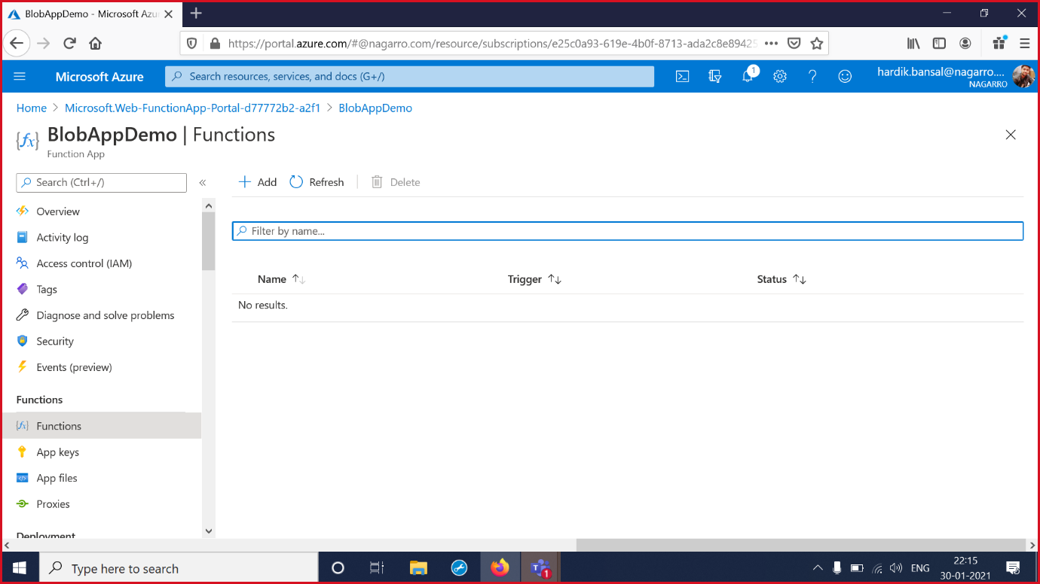

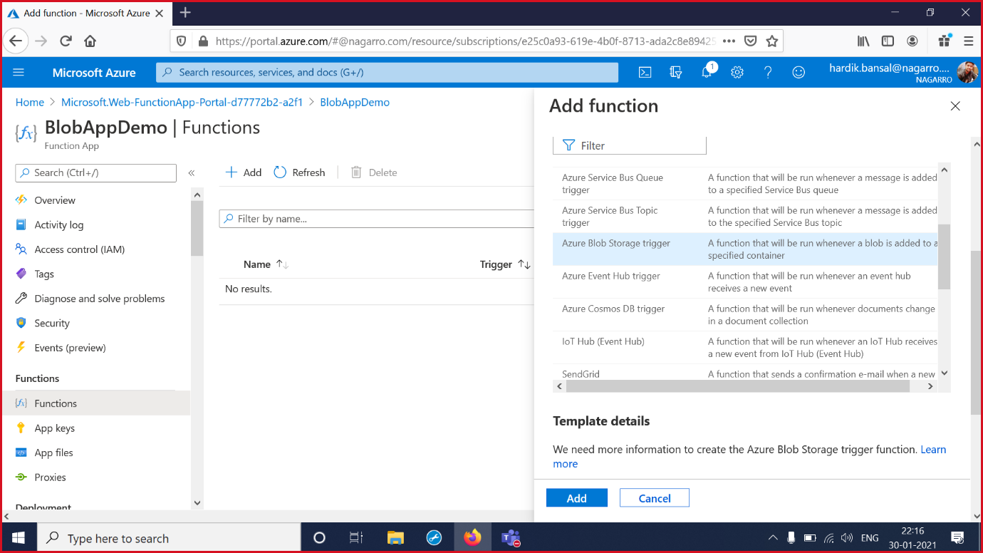

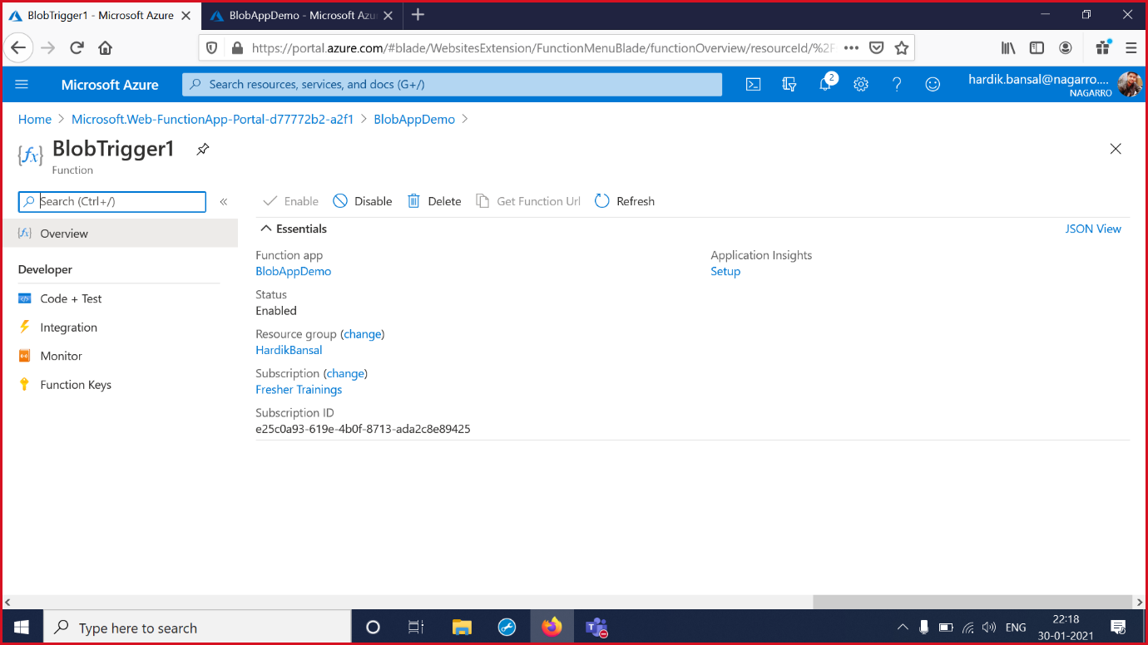

5.Select Code + Test ,Select function.json. Check the Log.

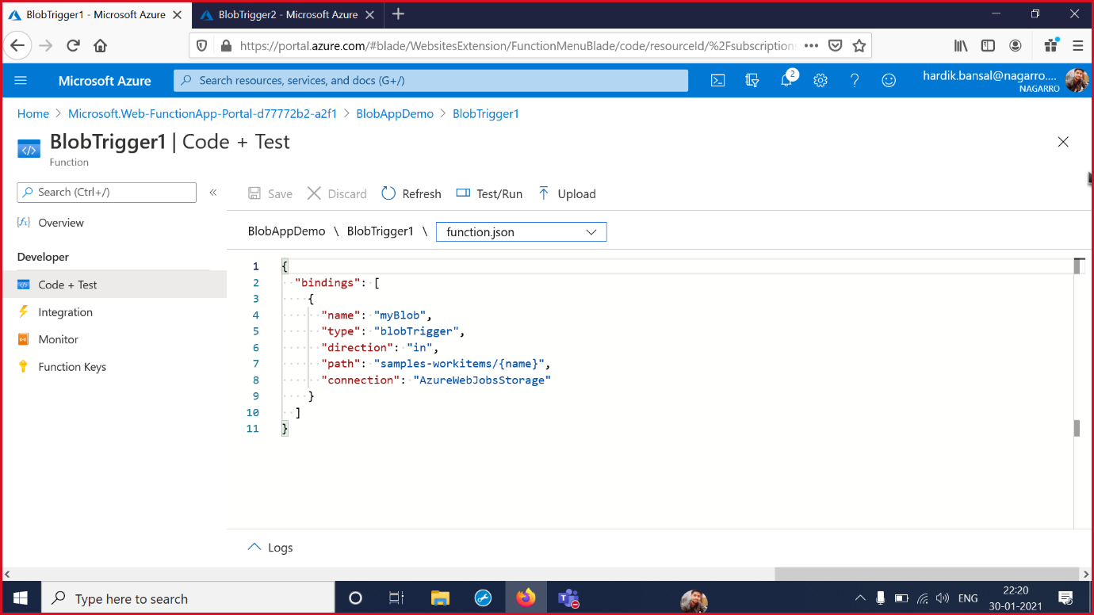

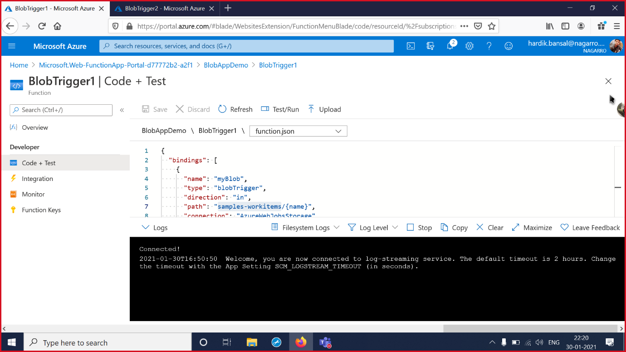

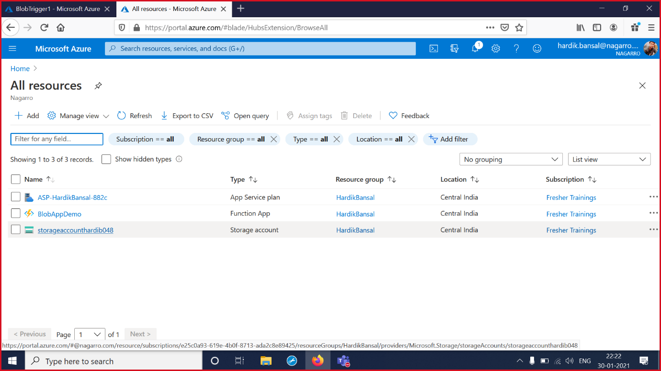

6.Select storage account and then Select storage explorer . Select the Blob container and add new blob Container with name samples-workitems and create the container.

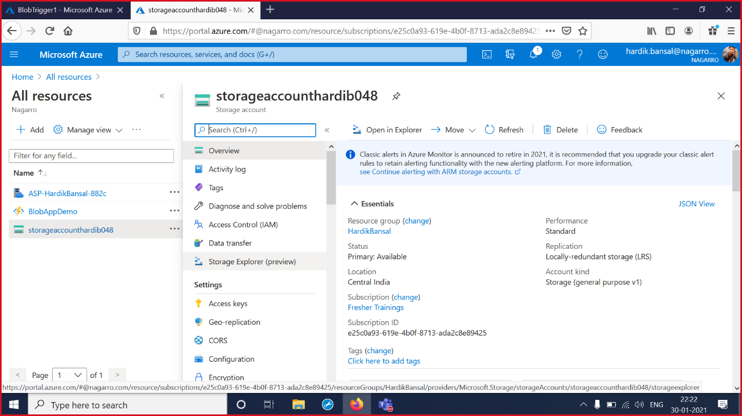

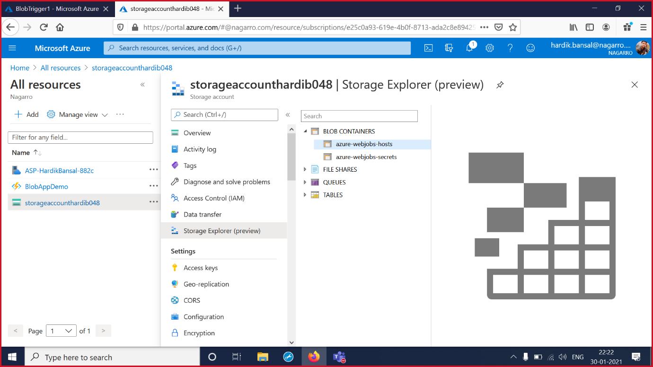

\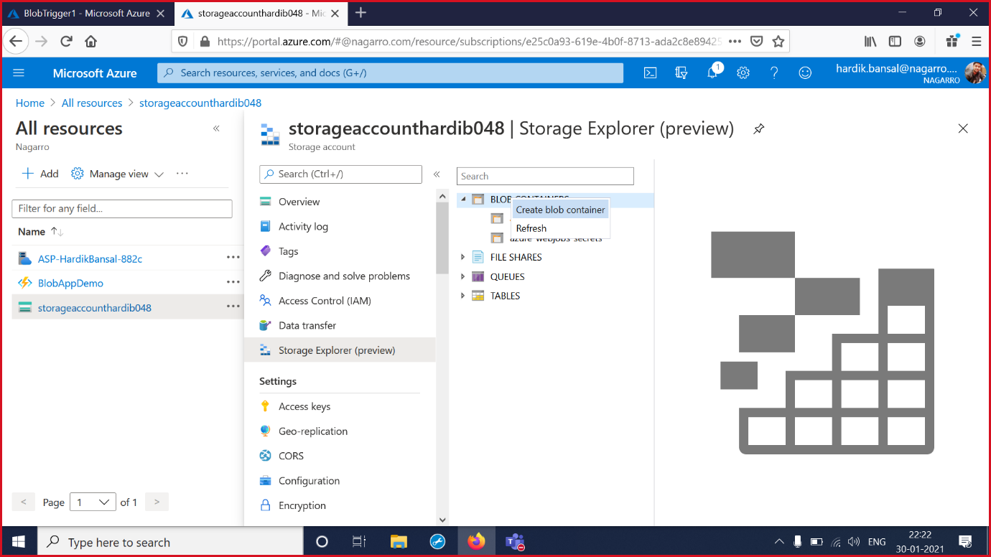

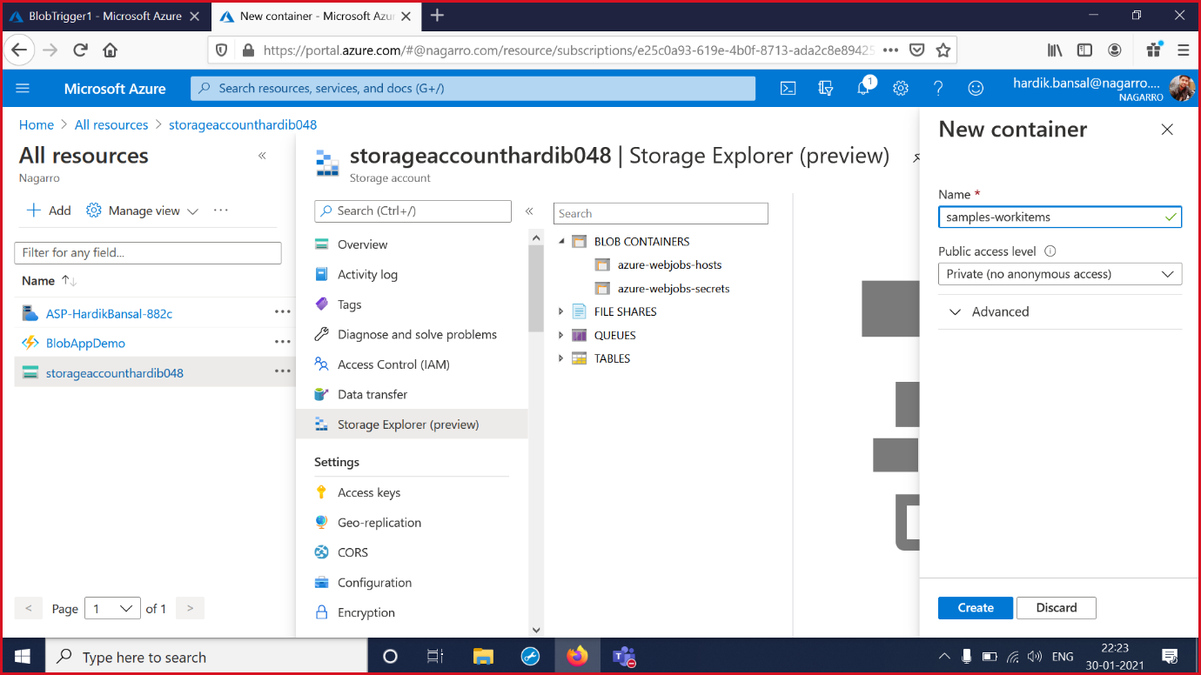

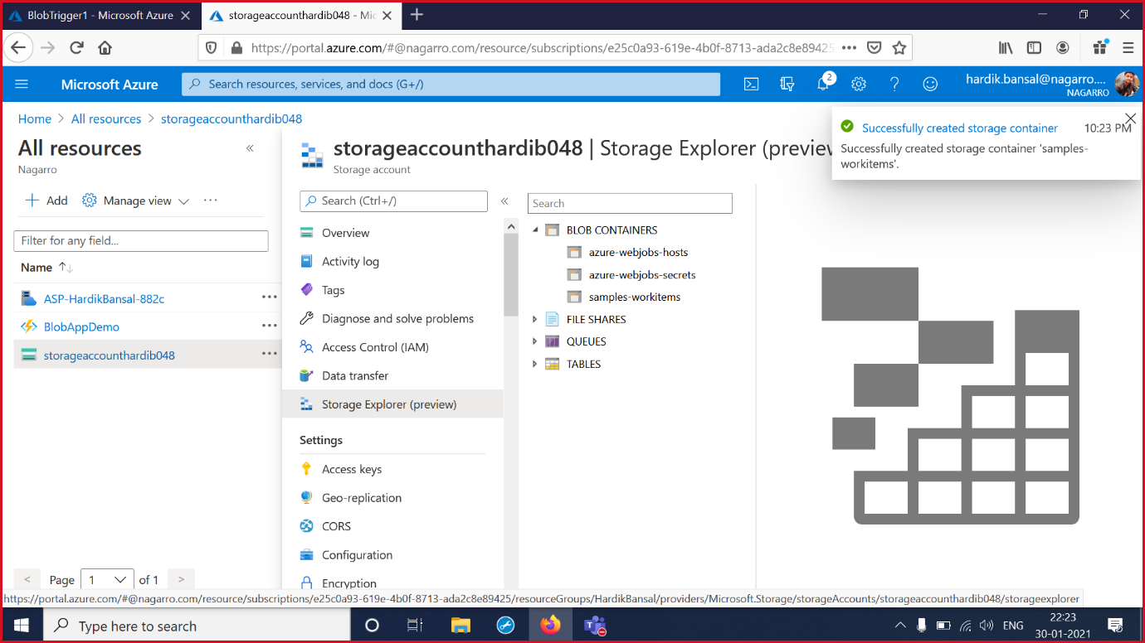

7.Select the generated container .Upload a file to the container and Check the logs showing the same name as the Upload file.

